**Daily Scrum or Standup Meeting**

Team name: Alpha Squad

Scrum Master: Ben Taylor

Date: Oct 21, 2019

|  |  |  |  |
| --- | --- | --- | --- |
| **Team Member** | **What did you do since the last scrum?** | **What do you plan to do before the next scrum?** | **What obstacles do you have?** |
| Alex Beeston | created class, template, and view for rules page. | Coordinate with whomever is in charge of the user’s page so that we can create a link from the user’s home page to the rules page. | I don’t know how to make an editable textbox. Does this use javascript? I still don’t know it that well. I could just make a link to a text field and they could start over, maybe. |
| Joey Carlisle | Created basic pages, set up urls/views, got a django template system in place | work on the models and start on the items list | Need to figure out how we want to figure out |
| Isaak Johnson | Nothing, but I have looked over my past django projects | Make it so the admin can see links to their pages,  make it so an admin can start/stop an auction. | None |
| Ben Taylor | Created a basic login layout. It’s super rough and needs prettying up and connection to the backend. | Finish up the login page with all needed connections to the backend, such as cookies | Homework from other classes due before others |
|  |  |  |  |

# Burndown

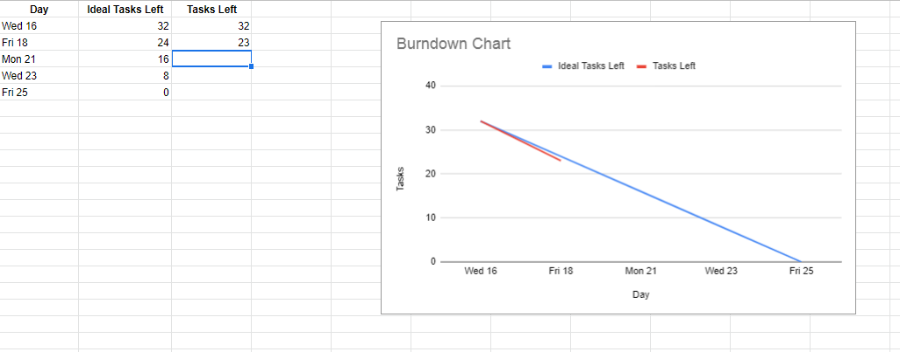

# Screenshot of you project board

